Topic: Automobile Collisions

Name: Jose Fuentes

Vehicle’s Weight on Collisions

If you don’t own a car in the USA, you will soon face the challenge of traveling anywhere here. Along with the bad public transport and lack of walkable cities, having a car has become essential. With this in mind, we can’t ignore the hazards that come when being behind the wheel. “In 2021, 46,980 people died in motor-vehicle crashes compared to 42,338 in 2020 and 39,107 in 2019.” (NSC 2021)[1] Although this statement can’t be taken at face value, it’s still important to keep it in mind as fuel to motivate us to find any correlation related to motor-vehicle crashes.

Thus, methods from the study of casual Inference can help us tackle this problem. It’s crucial to run some analysis that can guide us in the right direction to lower the number of casualties on the road through significant variables. My main research question asks, **do large vehicles on the road cause an increase in accidents in NYC?** From this we clearly have a cause and an effect. The size of the vehicle and the collision. I will use data from all police reported car crashes in NYC. In this dataset we have a variable named VEHICLE TYPE CODE 2, seen in figure 1, which goes more in detail about the labels of vehicles between an ATV, bicycle, car/SUV, ebike, escooter, truck/bus, motorcycle, and others. I mainly want to look at trucks and sedans on the road and the number of people injured. Will there be a correlation to higher amounts of vehicles that are larger?

For this project I decided to work alone. I think the best method to use is Regression Discontinuity, to see if there’s a threshold for the weight of a vehicle and the collision. I'm open to other methods, but I feel as though I need to come up with a question that will fit the other methods. As for the NYC dataset, it didn’t contain weights for sedans or trucks so i had to find an auxiliary dataset to find vehicle weights for sedans and trucks. This will help me determine a threshold to see whether there is a sharp cut off. I believe that larger weighing cars will cause more injuries because they take longer to stop in an emergency.

Some confounding variables to keep in mind would be male vs female drivers, disabled or abled drivers, age, and weather. Although it’s important to keep these actively in your mind while exploring the data, we can’t really control them.

A research paper on a similar topic titled, “Passenger car collision fatalities – with special emphasis on collisions with heavy vehicles”. It was shown that vehicles like buses and trucks compared to cars will have higher damage to other cars. It’s important to point out that these collisions were crashes in the oncoming vehicle’s lane, under icy, snowy, or wet conditions. As well as it was conducted in Sweden.

Figure 1:

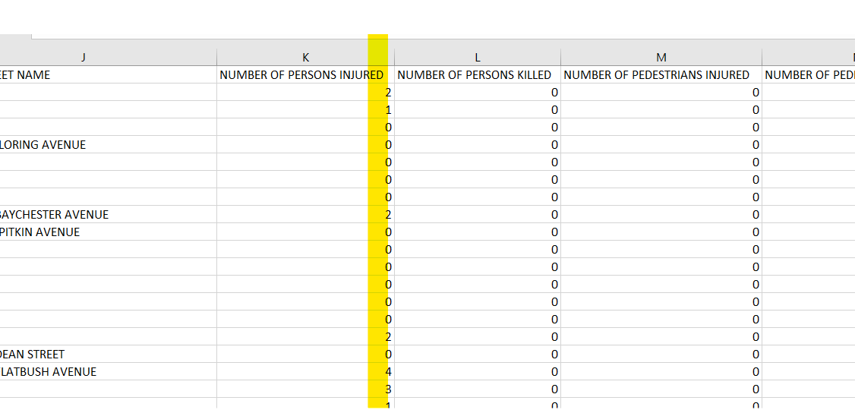

**Primary Data**:

<https://catalog.data.gov/dataset/motor-vehicle-collisions-crashes>

**Auxiliary Dataset:**

<https://archive.ics.uci.edu/dataset/10/automobile>

**Cite**:

National Safety Council. (2024). Motor vehicle: Overview: Introduction. Injury Facts. <https://injuryfacts.nsc.org/motor-vehicle/overview/introduction/#:~:text=%C2%A0In%202021%2C%2046%2C980%20people%20died%20in%20motor%2Dvehicle%20crashes%20compared%20to%2042%2C338%20in%202020%20and%2039%2C107%20in%202019>.

Björnstig, U., Björnstig, J., & Eriksson, A. (2007). Passenger car collision fatalities – with special emphasis on collisions with heavy vehicles. Accident Analysis & Prevention, 39(3), 678-687.

1. <https://injuryfacts.nsc.org/motor-vehicle/overview/introduction/#:~:text=%C2%A0In%202021%2C%2046%2C980%20people%20died%20in%20motor%2Dvehicle%20crashes%20compared%20to%2042%2C338%20in%202020%20and%2039%2C107%20in%202019>.